Test – Cafeto - SuperHero

17 de marzo de 2021

Alfonso Lopez hidalgo

# Instalation Manual

Tabla de contenido

Instalation Manual 1

Install Plugins 2

1. Beaver builder 2

2. superheroe 2

3. superheroe-one 3

How to Use the Plugins 4

1. Access to wordpress with editor credentials 4

2. Go to Beaver Builder and deploy your rows and columns 4

3. Deploying the plugins 4

Example SuperHero One 6

## Install Plugins

### Beaver builder

* 1. Upload Beaver builder to server/wordpress_installation/wp-content/plugins/
  2. Go to Wordpress Dashboard/plugins



* + 1. Activate the plugin (Beaver Builder Plugin (Pro Version))



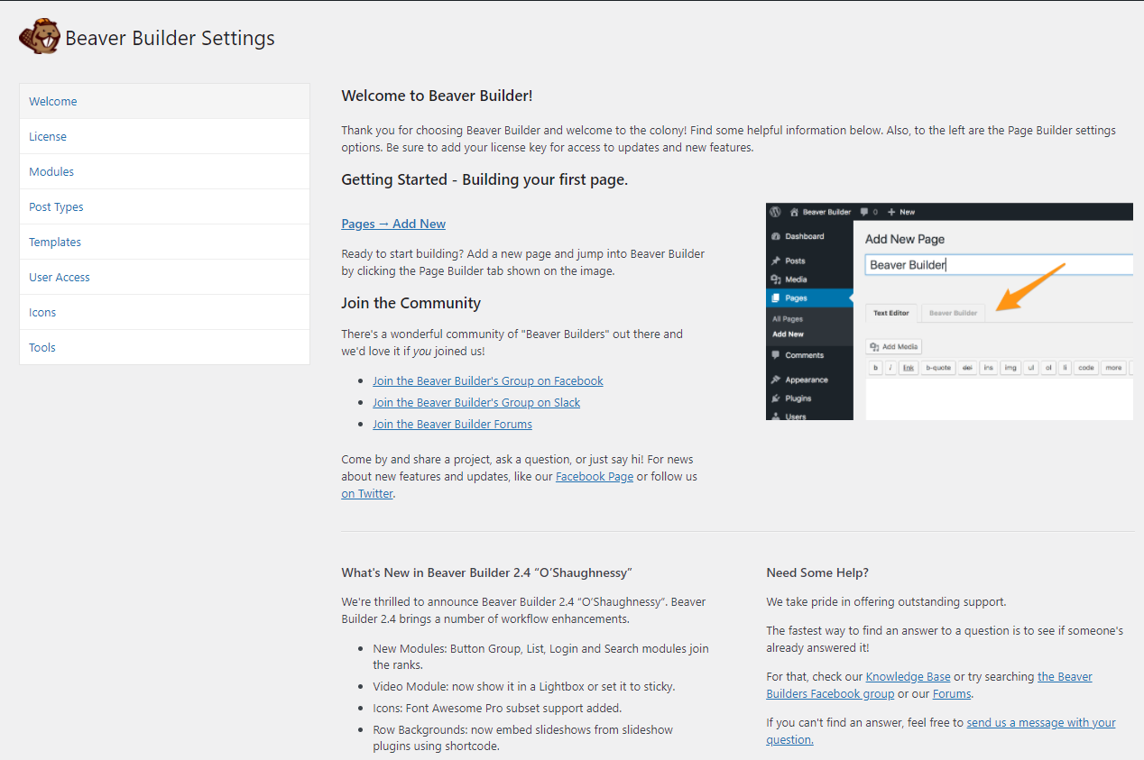

### superheroe

* 1. Upload Beaver builder to server/wordpress_installation/wp-content/plugins/
  2. Go to Wordpress Dashboard/plugins



* + 1. Activate the plugin (SuperHero plugin)



### superheroe-one

* 1. Upload Beaver builder to server/wordpress_installation/wp-content/plugins/
  2. Go to Wordpress Dashboard/plugins



* + 1. Activate the plugin (SuperHero One plugin)



## How to Use the Plugins

### Access to wordpress with editor credentials

### Go to Beaver Builder and deploy your rows and columns

* 1. In front end page, clic in the menu “Beaver Builder”



* 1. Clic in + Button



In this section you will see all the options that you have to build a page with Beaver Builder, you can decide how many rows and columns you want to use for your sections.

### Deploying the plugins

* 1. Scroll down to the section “Super Heroes”

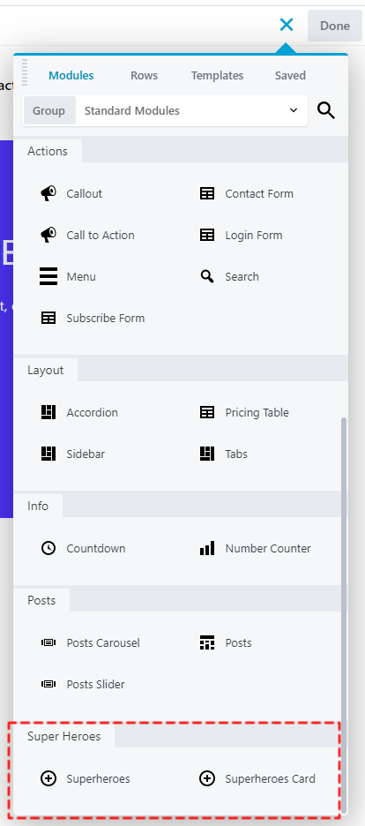

* 1. Select the plugin you want to display by dragging and dropping the plugin
  2. In the windows, you can text the name of the super hero you want to display, for example “superman”

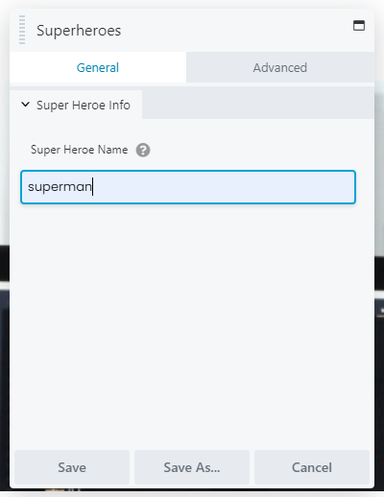

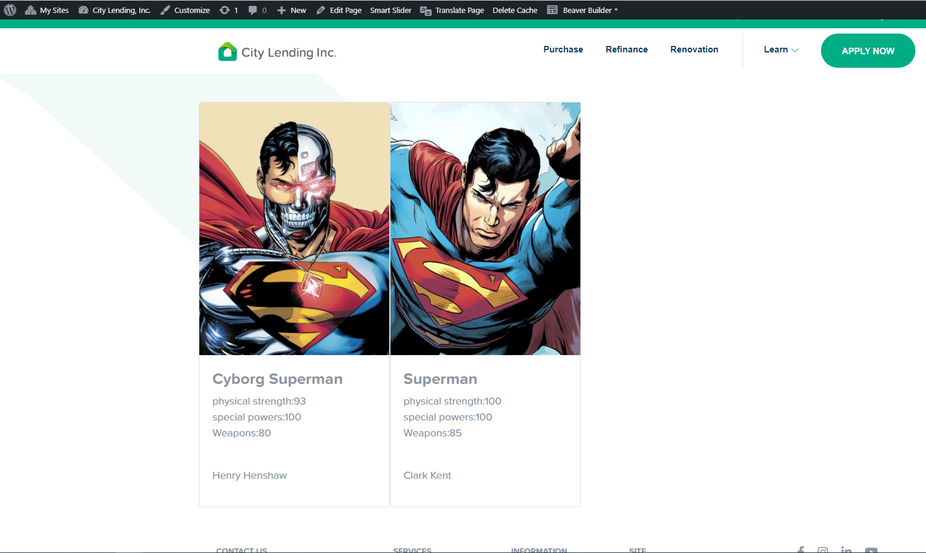

### Example SuperHero One

